**AVC Progress Report**

*ENGR 101, 2019 T1*

**Name:** Connor de Bruyn

**Student Number:** 300499023

**Lab day & time:** Mondays 10am-12pm (A1)

**Abstract**

Our Autonomous Vehicle Challenge (AVC) is the task in which we design and create a model of a car that can detect obstacles and pathways in order to avoid them. As a team of 5, we will continue to manage and perform tasks through each lab until the completion of the project. So far our project has done …. We will continue to work on the rest of the requirements until the finish of the project. From the results we have gathered at this current moment we can say that the finish line is definitely

*The abstract is a brief summary of the report and contains the scope, motivation, results, the meaning of the results and the conclusion. The abstract is the first thing a person will read in your report. It is important to present the information in a clear, succinct manner to entice the viewer into reading your report.*

**Introduction**

Our AVC project aim is to recreate a realistic model of a “self-driving” car with the given components such as a raspberry pi and a camera. We have divided our team into 3 groups to work on Hardware (designing and creating the car model), Software(programming the raspberry pi to perform tasks) and Testing (monitor progress of car and record results). As a group, we are determined in order to make a working model which can complete all the quadrants in the given timeframe. Through teamwork, we can work together to find solutions for any problems that arise such as faulty design or ineffective coding so that we can fulfill our objective, clearing all quadrants.

Scope of report – what it will cover

Motivation - why you doing this

Aim- create robot that does (broad terms) (what we want to do)

Objective – how we will do aim (work in team to..), als measureable outcomes (ie robot will complete q 2, we will complete this)

Anticipated benefits – working in a team

*The introduction can be treated as a sequence of subsections containing a scope, motivation, aim, objective and anticipated benefits. The intention is to present the problem to be solved and the motivation behind the problem. The scope defines what will be covered in the study.*

**Background**

Throughout the project, we use multiple tools and resources in order to achieve our objective. These tools include:

* Raspberry Pi - a mini circuit board able to do basic functions that a standard computer is capable of. It is the foundation of the project where the code is to be stored and run from. It is able to send data/voltages through to inputs in order to perform actions.
* Camera - a 320x240 pixel camera which is able to differentiate colors of a pixel through functions obtained from the E101 library.
* C++ - The programming language that we use to compile and run on the raspberry pi. Run from the “geany” program.
* Servos - Motors that can rotate 360 degrees which can turn the camera and the wheels of the car.
* 3D Printer – to create some of the parts for the vehicle. It can print components designed using the FreeCad software that are the slt file format.

By attaching all the physical components together onto a car chassis, we can then create methods that make the vehicle do various activities (Ie turning, detecting lines, etc).

This would then enable us to complete each quadrants task. In the first quadrant the robot has to open the gate by obtaining a password from the server over Wi-Fi and send it back to the sever. Quadrant 2 involves following a curvy line. In quadrant 3 the robot has to follow a straight line, make shard turning, and make decide which direction to go. In quadrant 4 the robot needs to come close to the coloured cylinders and then proceed to the finish line.

We will work in a team of 5 in different roles to create and code the robot in three weeks. Each of us has two 2hr labs each week to work on this robot.

SHOULD PROBABLY WRITE ABOUT HOW THE CODE THAT FOLLOWS THE LINE WORKS

*The background provides an introduction to the subjects that the reader needs to know to understand the report. It need not contain a literature review but it can contrast the alternatives to the approach of this report.*

**Method**

**Planning**

We spent our first lab planning. We decided on roles for each person (insert roles here) and a timeline for what we would be doing each week in the labs. ( roughly insert the timeline here). A group chat was created so that we could communicate with each other and we created a GitHub repository so that we could share code in a way that has versioning.

**Hardware**

For our hardware, we started by designing a chassis that would fit all the required parts as well as having enough structure to hold them.

We created individual parts by either 3D printing them or by using pre-existing parts that were provided. This allowed us to trial each piece before being added to the design, if some parts didn’t fit or were faulty in any way, then we didn't lose progress. We will know if the design is complete once all the pieces have been attached and the model is able to be functional through the software that will be inputted.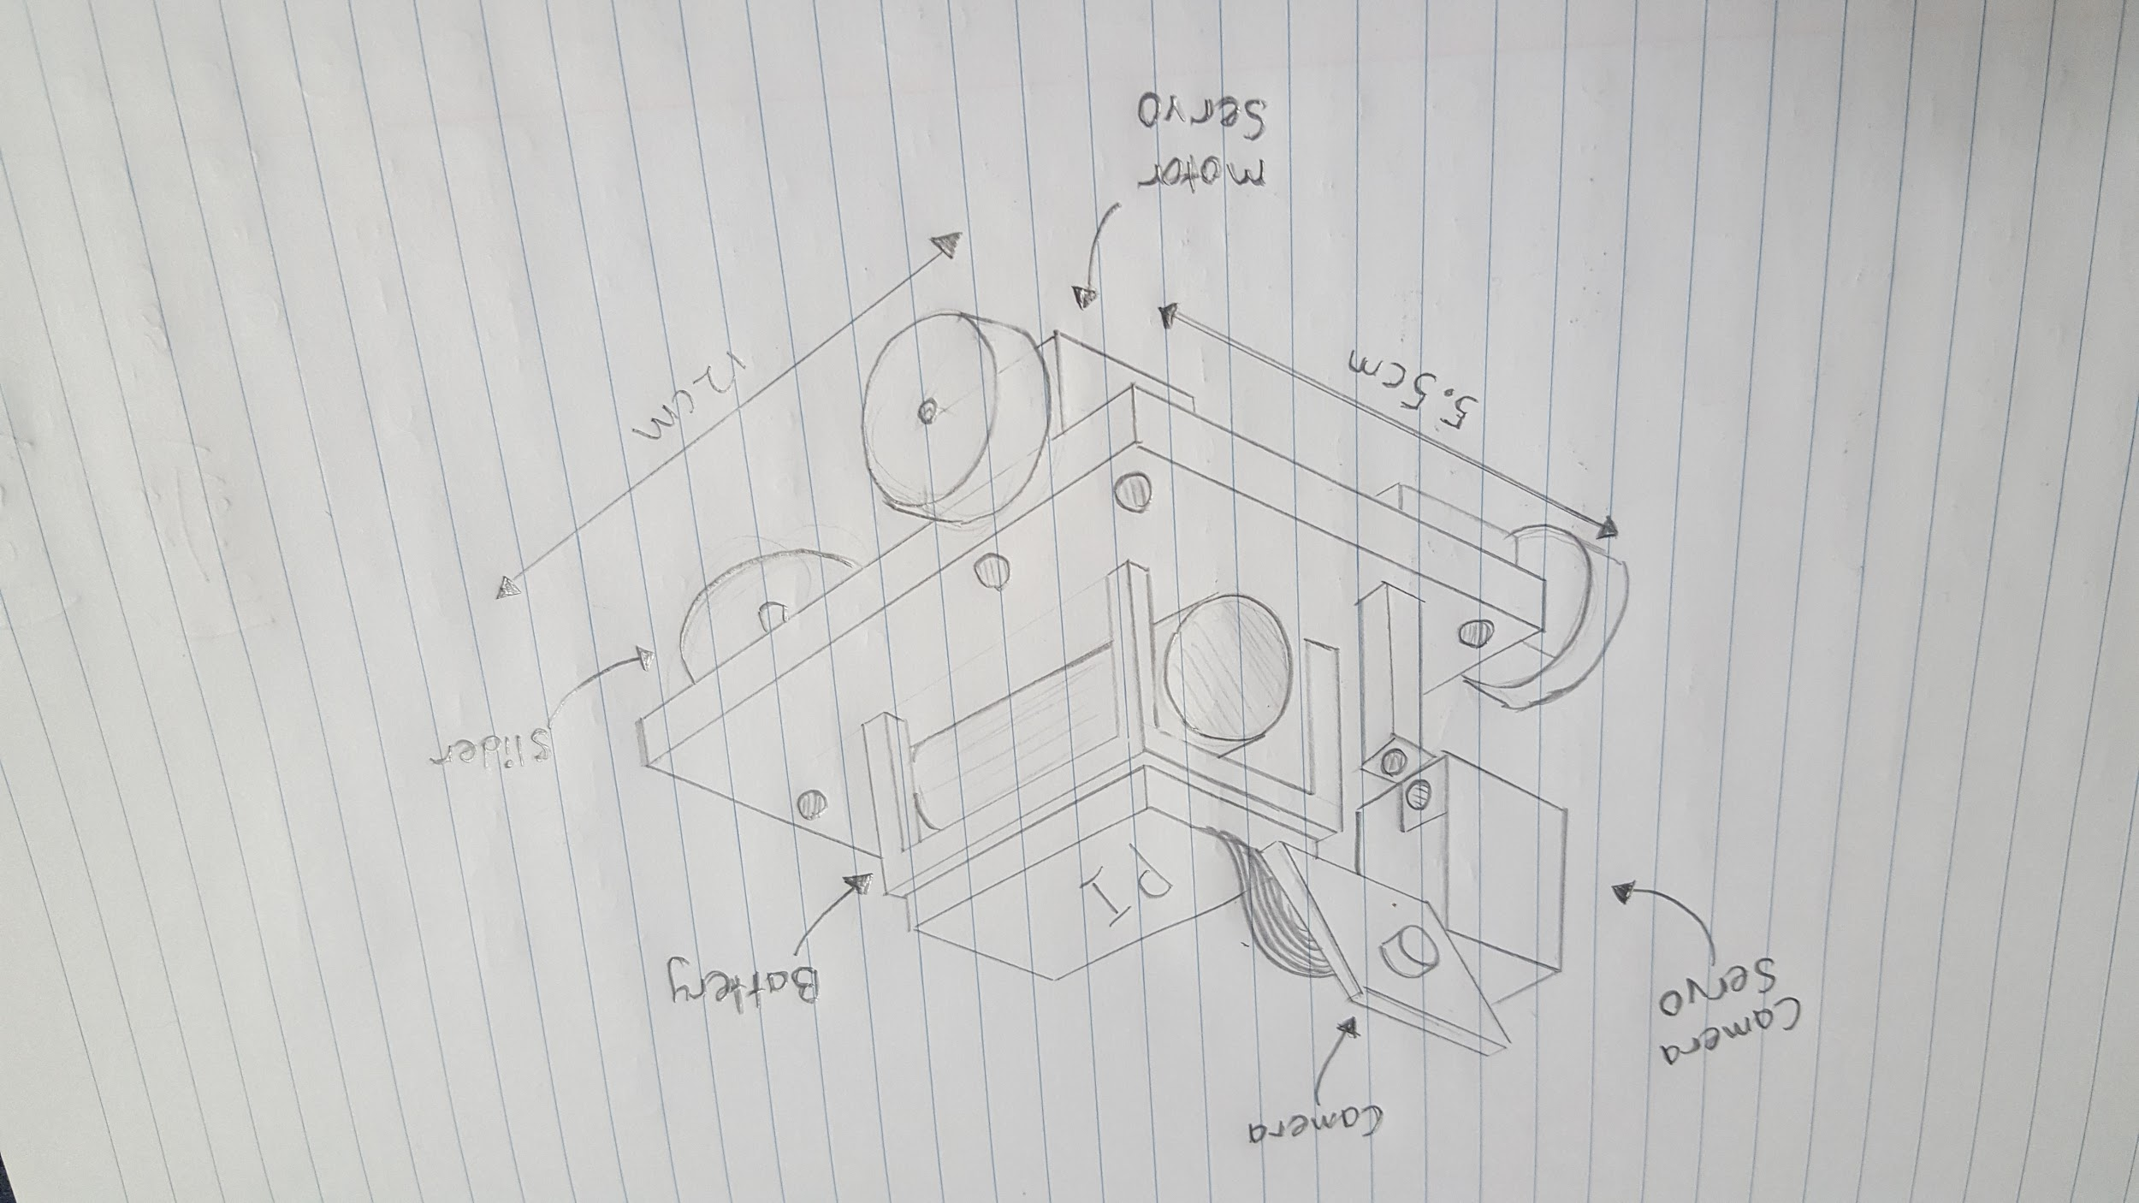

**Software**

**Testing**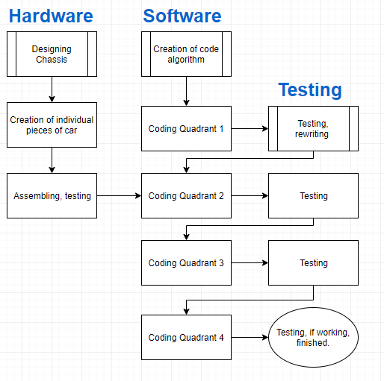

*The method explains how you did the experiment or study or project in sufficient detail that the experiment or project can be reproduced. Diagrams, schematics and pseudo code are often included. It is not to be written as a step-by-step guide.*

# 

**Results**

**Quandrant one**

**Part of a robot**

*The results section should state the results and the important details of the experiment or project. This section may contain tables and graphs of the collected data. If the experiment was to compare simulated results against real life then graphs with both results on the same axis would be useful here.*

**Discussion**

**What hasn’t worked**

*Normally, the discussion section should explain the results and the position taken on the experiment or project. For example, why was the finish of the printed object stringy? How could the finish be improved? Comparisons against previous studies or expected results can be discussed here.*

**Conclusion**

*This section should state what was found, why it is important, possible benefits and the position the experiment takes.*

*It seems we don’t have to write a conclusion for the progress report*

**References**

Raspberry pi Official Website

<https://www.raspberrypi.org/help/what-%20is-a-raspberry-pi/>

*Please add good references here using APA referencing style. Some examples are included below to show the expected style.*

*Barlow, C. 2008, Key concepts in computing,* Oxford University Press, Auckland.

Curtis, M. J. 2002, ‘Experimental design’, *Journal of Engineering,* vol. 12, no. 4 , p. 45 *.*

Gregg, B. & Wilkins, R. 2005, ‘The development of skills teaching in engineering, programs in New Zealand universities’. *Education Quarterly,* vol. 36, no. 1, pp. 57-72, (online EBSCO database).